So now we are going to use the Convolution method. It can be represented as.

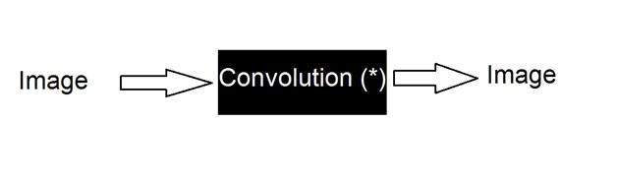

It can be mathematically represented as two ways

**g(x,y) = h(x,y) * f(x,y)**

It can be explained as the “mask convolved with an image”.

Or

**g(x,y) = f(x,y) * h(x,y)**

It can be explained as “image convolved with mask”.

There are two ways to represent this because the convolution operator(*) is commutative. The h(x,y) is the mask or filter.

What is mask?

Mask is also a signal. It can be represented by a two dimensional matrix. The mask is usually of the order of 1x1, 3x3, 5x5, 7x7 . A mask should always be in odd number, because otherwise you cannot find the mid of the mask. Why do we need to find the mid of the mask. The answer lies below, in topic of, how to perform convolution?

How to perform convolution?

In order to perform convolution on an image, following steps should be taken.

* Flip the mask (horizontally and vertically) only once
* Slide the mask onto the image.
* Multiply the corresponding elements and then add them
* Repeat this procedure until all values of the image has been calculated.

Example of convolution

Let’s perform some convolution. Step 1 is to flip the mask.

Mask

Let’s take our mask to be this.

|  |  |  |
| --- | --- | --- |
| 1 | 2 | 3 |
| 4 | 5 | 6 |
| 7 | 8 | 9 |

Flipping the mask horizontally

|  |  |  |
| --- | --- | --- |
| 3 | 2 | 1 |
| 6 | 5 | 4 |
| 9 | 8 | 7 |

Flipping the mask vertically

|  |  |  |
| --- | --- | --- |
| 9 | 8 | 7 |
| 6 | 5 | 4 |
| 3 | 2 | 1 |

Image

Let’s consider an image to be like this

|  |  |  |
| --- | --- | --- |
| 2 | 4 | 6 |
| 8 | 10 | 12 |
| 14 | 16 | 18 |

Convolution

Convolving mask over image. It is done in this way. Place the center of the mask at each element of an image. Multiply the corresponding elements and then add them, and paste the result onto the element of the image on which you place the center of mask.

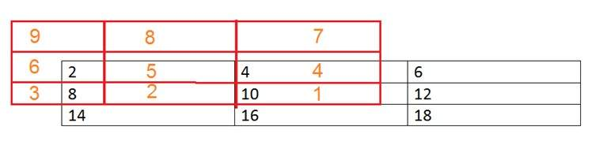

The box in red color is the mask, and the values in the orange are the values of the mask. The black color box and values belong to the image. Now for the first pixel of the image, the value will be calculated as

First pixel = (5*2) + (4*4) + (2*8) + (1*10)

= 10 + 16 + 16 + 10

= 52

Place 52 in the original image at the first index and repeat this procedure for each pixel of the image.

Why Convolution

Convolution can achieve something like the blurring, sharpening, edge detection, noise reduction e.t.c.

**Convolution**

Linear filtering of an image is accomplished through an operation called *convolution*. Convolution is a neighborhood operation in which each output pixel is the weighted sum of neighboring input pixels. The matrix of weights is called the *convolution kernel*, also known as the *filter*. A convolution kernel is a correlation kernel that has been rotated 180 degrees.

For example, suppose the image is

A = [17 24 1 8 15

23 5 7 14 16

4 6 13 20 22

10 12 19 21 3

11 18 25 2 9]

and the correlation kernel is

h = [8 1 6

3 5 7

4 9 2]

You would use the following steps to compute the output pixel at position (2,4):

1. Rotate the correlation kernel 180 degrees about its center element to create a convolution kernel.
2. Slide the center element of the convolution kernel so that it lies on top of the (2,4) element of A.
3. Multiply each weight in the rotated convolution kernel by the pixel of A underneath.
4. Sum the individual products from step 3.

Hence the (2,4) output pixel is

http://in.mathworks.com/help/images/linfilt14.gif

Shown in the following figure.

**Computing the (2,4) Output of Convolution**

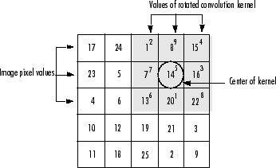

**Correlation**

The operation called *correlation* is closely related to convolution. In correlation, the value of an output pixel is also computed as a weighted sum of neighboring pixels. The difference is that the matrix of weights, in this case called the *correlation kernel*, is not rotated during the computation. The Image Processing Toolbox™ filter design functions return correlation kernels.

The following figure shows how to compute the (2,4) output pixel of the correlation of A, assuming h is a correlation kernel instead of a convolution kernel, using these steps:

1. Slide the center element of the correlation kernel so that lies on top of the (2,4) element of A.
2. Multiply each weight in the correlation kernel by the pixel of A underneath.
3. Sum the individual products.

The (2,4) output pixel from the correlation is

http://in.mathworks.com/help/images/linfilt17.gif

**Computing the (2,4) Output of Correlation**

